**Kickstarter Analysis**

**Pete Farquhar**

8-24-19

**1. Given the provided data, what are three conclusions we can draw about Kickstarter campaigns?**

**Conclusion One-- What are the most successful categories?** Music and Theater are the most successful categories. Music Kickstarters have the highest percentage success rate while Theater has the highest absolute number of successful campaigns. Fully 77% of Music Kickstarters succeed, well above the 53% average across all categories. Theater had 839 successful campaigns, far ahead of any other category, but 530 failed or cancelled campaigns led to a lower 60% success rate.



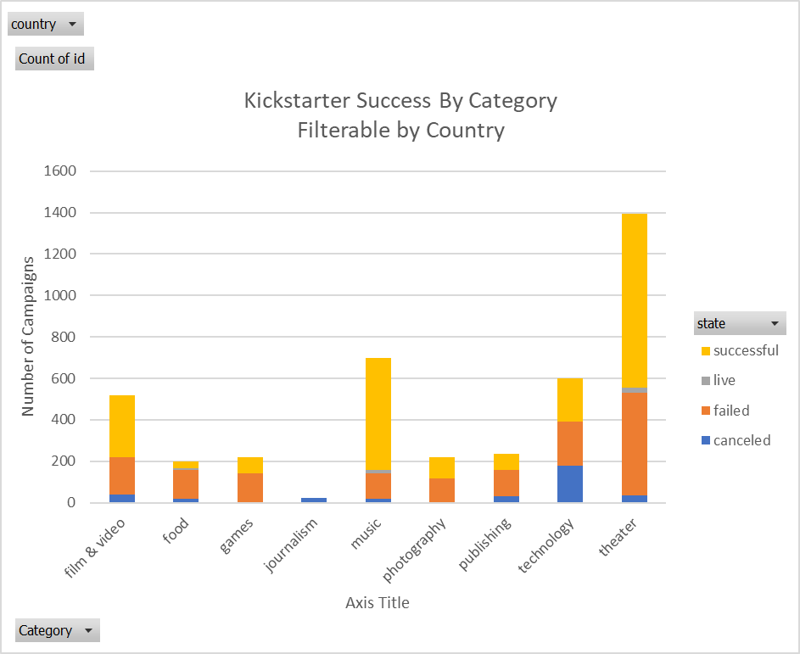

**Conclusion Two-- What are the most successful sub-categories?** Rock, documentary film, and tech hardware are the three sub-categories that have more than 100 campaigns and a 100% success rate. Plays have the highest absolute number of successes, at 694, but only a 65% success rate.

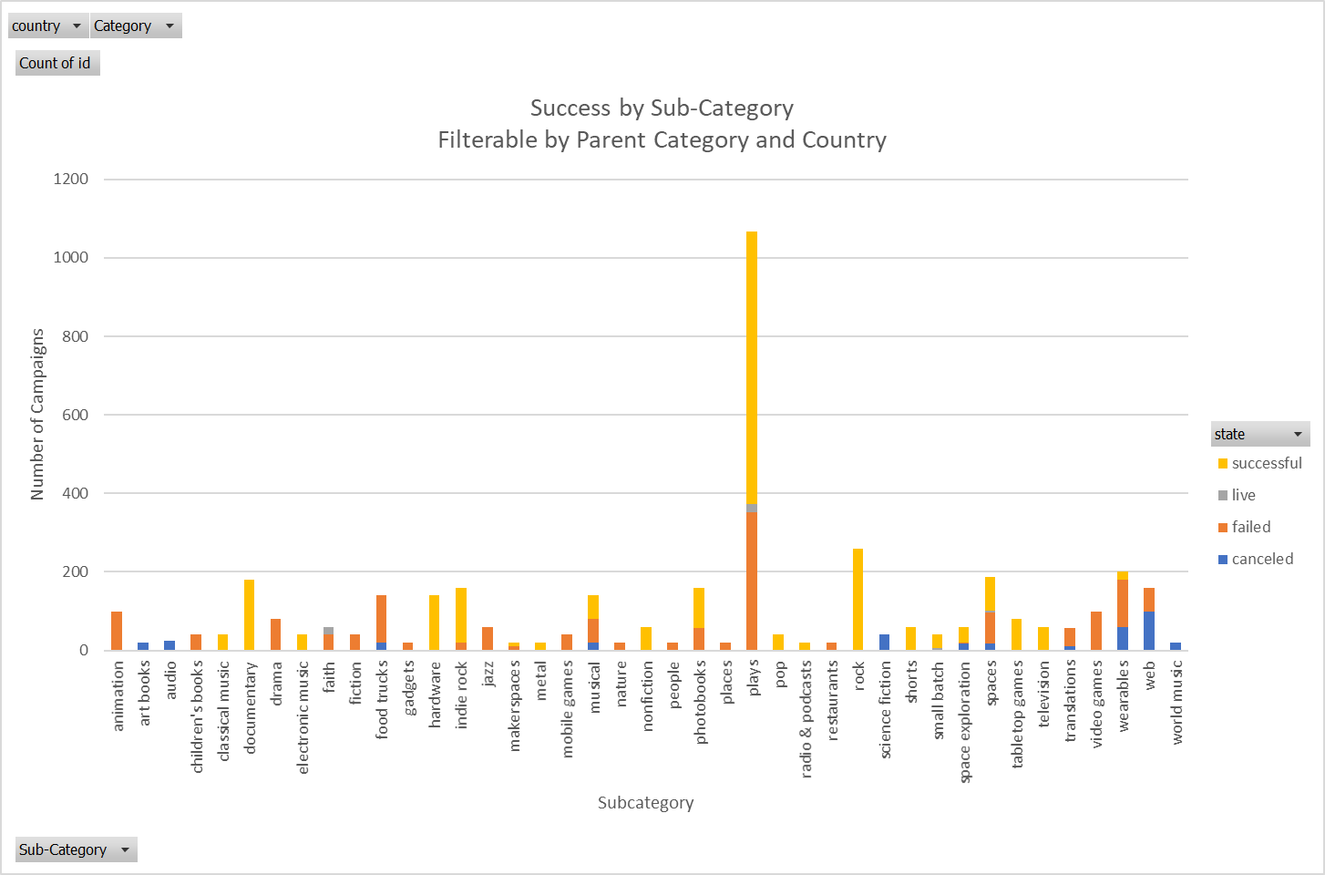

**Conclusion Three: What should I not do a Kickstarter for?** Journalism had the lowest category success rate, at a dismal 0%, but only 24 campaigns. Food was next worst with a brutal 17% success rate with 200 campaigns. Videogames, animation, food trucks and web campaigns each had more than 100 campaigns and a 0% success rate. Wearables, one of the largest sub-categories at 200 campaigns, had only a 10% success rate. Many fields widely seen as trendy, such as food trucks and wearables, were not able to convert that to success on Kickstarter.

**2. What are some limitations of this dataset?**

Many campaigns set low goals that made success much more likely. In looking at success by sub-category it probably makes sense to separate out very small campaigns, especially if you are looking at something for business purposes.

Also, there is no way to know the seriousness/quality of the campaigns. For example, there could just be lots of low-quality, hasty wearables projects on Kickstarter—a good quality wearable project shouldn’t be discouraged by the low success rate.

**3. What are some other possible tables and/or graphs that we could create?**

Success by country, success by year, average pledge by country or category. Etc.

The Bonus Exercise shows general trend of success falling by goal size:

